TECHNICIAN PRODUCTIVITY GUIDELINES
PRODUCTION PER TECHNICIAN PER DAY

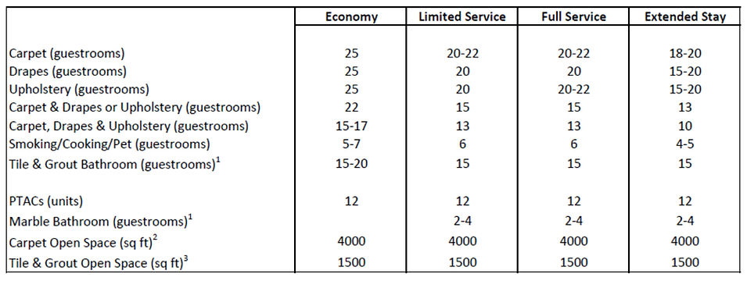

Notes
- ¹Assumes bathroom floor is not being done at the same time as any other service in the guestroom.
- ²Carpet Open Space includes banquet rooms, hallways and other large spaces where movement of equipment is not required.
- ³Tile & Grout Open Space includes the lobby and any other large spaces where movement of equipment is not required. Kitchen space takes longer.
- These are not requirements, but rather achievable guidelines based on our history of experienced technicians.
- This productivity assumes that all rooms are in a contiguous fashion and accounts for the necessary stops to fill and empty the machines.
- New technicians are 25-50% less productive than experienced ones.
- Suites and two bedroom units take approx. 33% longer to complete than a standard room.
- An 8 hour shift is approx. 6.5-7 hours of actual work time plus breaks and set up / tear town down times. Drive time to and from property is extra. Assumes rooms are in a consecutive order.
- Specialty stain removal like red wine, hair dye, etc. are not accounted for in these guidelines.
- Drapes does NOT include sheers. Add additional time if sheers are included at the same time as drapes.
- Square meters = square feet divided by 10.

